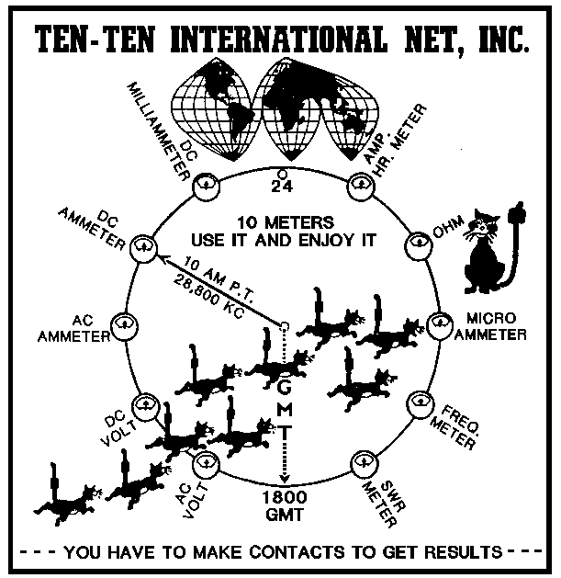
Ten-Ten International Net, Inc.
Application for Lifetime Membership

NAME: ____________________________________________ 10-10: ______________ CALL: ________________

ADDRESS: _____________________________________________________________ APT: _________________

CITY: ____________________________________________ STATE: ______________ ZIP: __________________

NOTE: ALL MEMBERSHIP DATA IS PROTECTED BY THE PRIVACY ACT OF 1974 AND WHERE APPLICABLE THE GENERAL DATA PROTECTION REGULATION. THE ONLY DATA AVAILABLE THROUGH LOOK UP SOURCES IS CONSIDER NON-PRIVATE.

Check one of the following Life Membership categories, and circle Payment plan

 | Plan ID | Fee Schedule
 | s
 | Life Membership | $365
 | Senior Life Membership  65 Years and older | $120

Plan 1 - Lifetime Membership in 10-10 International Net, Inc. Enclosed is check, money order in the amount indicated above under Plan 1.

Email Address for a payment reminder ______________________________

Method of payment - Check/Money Order. For Credit Cards you MUST use the online application

____________________________________________________ DATE : ____________________
APPLICANTS SIGNATURE:

Please mail completed application to:

Dave Ruch
Data Manager
PO Box 1110
Elephant Butte, NM 87935

Effective Date 11/1/2024

